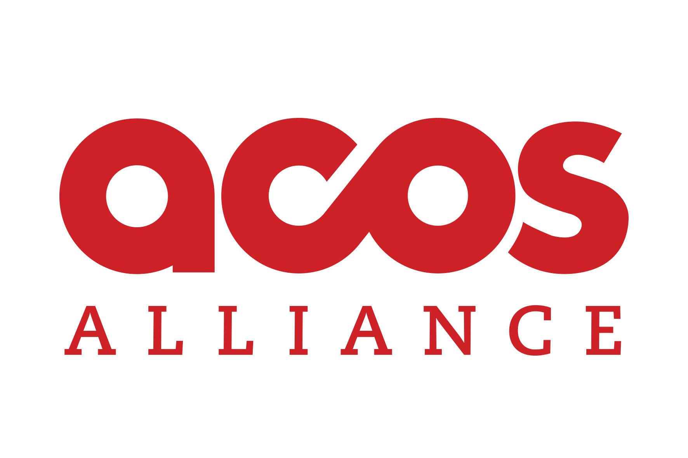

ASSIGNMENT SAFETY CHECKLIST

UKRAINE

Please use this form as a checklist to ensure editors and journalists have agreed on safety preparations for before, during, and after an assignment. For additional safety guidance and resources on risk assessment, insurance, and more, click here.

JOURNALIST NAME:

FREELANCE/STAFF/OTHER:

MEDIA OUTLET

EDITOR’S NAME:
TITLE & DESK:

STORY SLUG/SUBJECT:

ASSIGNMENT LOCATION(S):

ASSIGNMENT DATE(S):

ESSENTIAL DOCUMENTS

- Journalist has sent scan of passport and / or national identity document to editor.
- Journalist has obtained press credentials through the Ministry of Defense of Ukraine, as well as any special permission required for specific locations. (Be aware that, as the situation in Ukraine evolves, the requirements for press accreditation may change, and
the journalist may need to re-apply.)
- Editor / news outlet has provided journalist with assignment letter / required paperwork.
- Recent photos of journalist and each reporting team member have been sent to editor.
- Journalist has shared itinerary and relevant contacts with editor.
- Editor has shared an after-hours / emergency contact available 24/7.
- Journalist has identified, notified, and shared an emergency contact and / or next of kin, and has provided that person with an updated will, power of attorney, proof of life questions, and all login credentials, as well as specific instructions on what to do in the event of journalist’s injury, arrest, kidnapping, disappearance or death.

RISK ASSESSMENT + MITIGATION
[Attach risk assessment + communications plan]

- Journalist has completed safety and first aid training within the past two years.
- Other reporting team members have completed safety and first aid training within the
past two years.
- Editor and journalist have discussed story objectives (interviews, photos, video, social
media posts, etc.).
- Journalist and editor have researched the latest conditions in the assignment location, as well as checkpoints, frontlines, and entry and exit routes, and will continue to update
each other, and the risk assessment, as new information becomes available.
- Physical, psychological, digital, and legal risks have been discussed, and mitigation
measures suggested or enacted to lessen or eliminate those risks, where possible.

- Journalist and editor have assessed the availability of drinking water, food, secure lodging, medical aid, fuel, electricity, internet / mobile service, and nearest hardcover /
bunker in and around assignment location.
- Identity and personal profile-based safety considerations have been discussed.
- Journalist and editor have discussed risk tolerance and boundaries.
- Journalist and editor have discussed compliance with local, national, and wartime laws–including the sensitivity surrounding live broadcasts and social media posts–as well as how all members of the reporting team can best avoid criminal and civil liability
during reporting and after publication.
- Journalist and editor have discussed what legal resources the journalist would have access to if the journalist faces criminal or civil liability during reporting or after story
publication.
- Journalist and editor have discussed potential risks, safety protocols, risk tolerance /
boundaries, and contingency plans with each member of the reporting team.
- Journalist and editor have agreed on what news outlet will do to assist the journalist and the reporting team in case of emergency, or in the event the journalist is unable to
complete the assignment due to safety concerns.
- Editor and journalist have discussed and agreed on their responsibilities towards
reporting assistants / producers.
- Journalist's specific safety equipment needs, including PPE (helmet, flak jacket, mask,
etc.), have been discussed, agreed upon, and procured.
- All members of the reporting team have the necessary safety equipment, including PPE.
- A communications plan–including (but not limited to) regularly scheduled check-ins between journalist and editor, contingencies for areas without mobile / internet service, and escalation steps in case journalist fails to check in–has been written and agreed
upon.
- Main contact and communications methods for the assignment have been agreed upon.
- Contact information for all reporting team members has been shared with editor.
- Journalist has the required communications equipment (sat phone, burner phone, etc.)
and service for the assignment location, as well as power sources and batteries.

MEDICAL ILLNESS + INJURY
[Attach insurance details + emergency evacuation plan]

- Journalist and editor have discussed any medical conditions that may impact health and safety while on assignment.
- Journalist and editor have discussed access to health and injury insurance plans.
- Journalist will carry an appropriate first aid kit and has practiced using its contents.
- Nearest hospital, clinic, and / or aid station has been located and shared.
- Journalist will carry a paper copy of main contacts, emergency medical information,
and name and location of nearest hospital / aid station.
- Emergency evacuation plan has been discussed and agreed upon.
- Journalist has identified and confirmed the availability of a therapist, friend, or loved one who can provide psychological support before, during and / or after the
assignment.
- Editor and journalist have discussed psychological support and mental health resources.

EXPENSES + COMPENSATION

- Necessary assignment expenses have been discussed and agreed upon beforehand.
- Advance payment to journalist for expenses has been arranged by editor / news outlet.
- If advance payment of expenses is not possible, journalist has sufficient funds to
complete the assignment and for emergencies.
- A joint agreement has been reached for timely compensation and reimbursement of expenses.

